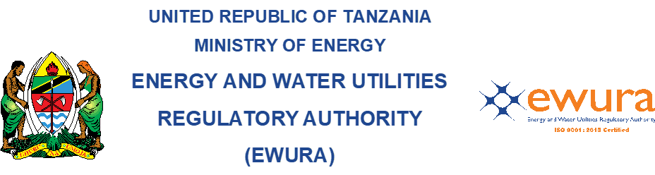

Energy and Water Utilities Regulatory Authority
(EWURA)

PUBLIC NOTICE

(Issued under section 19 of the EWURA Act, Cap. 414 and Rule 21(4) of the Petroleum (Wholesale, Storage, Retail and Consumer Installation Operations) Rules, GN No. 817 of 2020)

NOTICE is hereby given to the public that, EWURA has received an application seeking approval on transfer of a license of a petroleum retail outlet with the particulars set out hereinafter below:

Current name of the Station: Munif Ibrahim Khamis - Camel Mwakaganga Filling Station
Licence Number: PRL-2017-127
Physical Location: Plot No.2, Block 'H', Ubaruku Area, Mbarali District in Mbeya Region
Proposed change of name: Rak Energies Filling Station
Transferor: Munif Ibrahim Khamis T/A Camel Mwakaganga Filling Station
Transferee: Riyaz Mohamed Hussein Ahmed, Al Kabir Muradh Virji and Karim Kamrudin Alibhai T/A Rak Energies

Any person who wishes to make any representations or objections with respect to the application should do so in writing and submit to EWURA within fourteen (14) days from the date of publication of this notice. All representations or objections should be addressed to the address below.

Director General
The Energy and Water Utilities Regulatory Authority-EWURA

